Name Quang Huynh **CRQ Set # 1**

**Document 1**

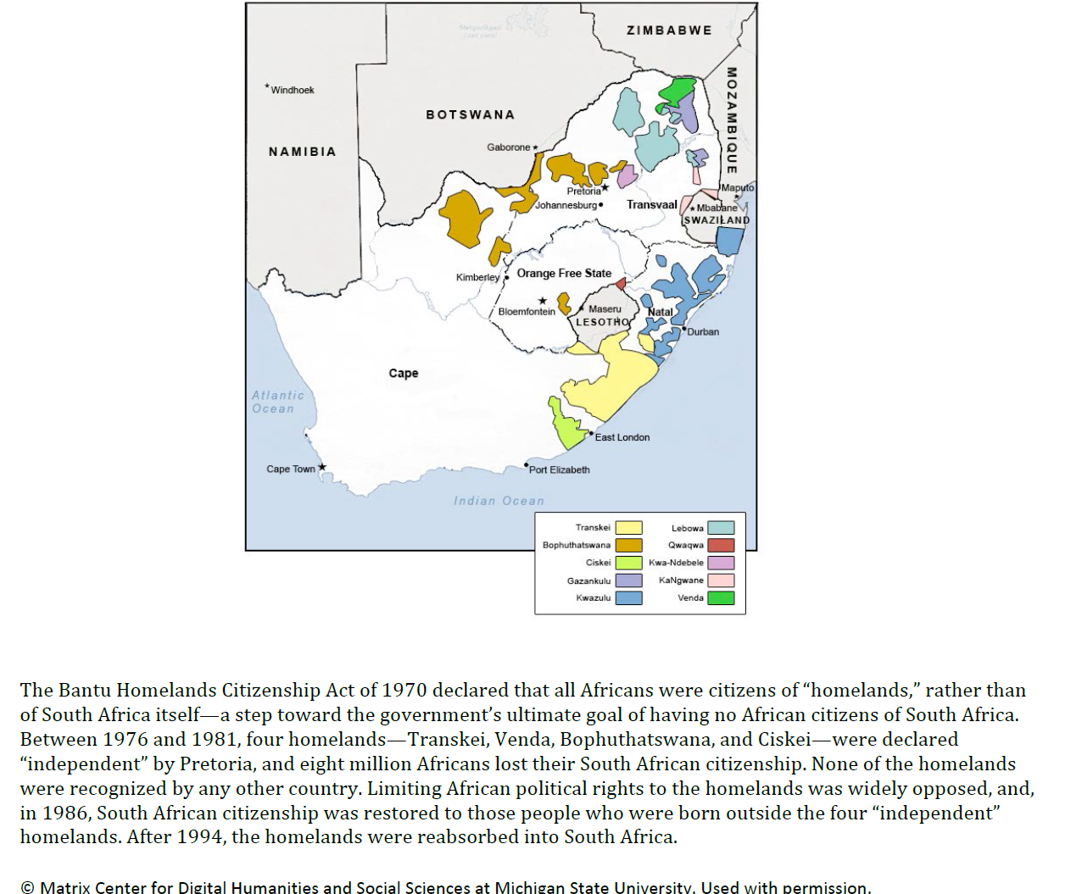

**Historical Context-**the historical circumstances surrounding this event/idea/historical development.

Using document 1, **explain** how the historical context affected a historical development in the document.

The South African apartheid caused this historical development to take place in the document. An apartheid is a system that discriminated and segregated non-white citizens of South Africa. As the goal of the apartheid is to eliminate as many non-whites as possible, and have no African citizens in South Africa, the Bantu Homelands Citizenship Act of 1970 stripped the Africans from their own country to live independently in another area. Africans who lived in these homelands had limited rights and privileges. The natives were mistreated and the government’s goal of removing the native’s citizenship seemed plausible by having the natives live in homelands.

**Document 2**

**Statement at a Special Meeting of the UN Special Committee Against Apartheid**

New York   June 22, 1990

These questions will arise because when this august body, the United Nations, first discussed the South African question in l946, it was discussing the issue of racism. They will be posed because the spur to the establishment of this organization was the determination of all humanity never again to permit racist theory and practice to dragoon the world into the deathly clutches of war and genocide.

And yet, for all that, a racist tyranny established itself in our country. As they knew would happen, who refused to treat this matter as a quaint historical aberration, this tyranny has claimed its own conclave of victims. It has established its own brutal worth by the number of children it has killed and the orphans, the widows and widowers it can claim as its unique creation.

And still it lives on, provoking strange and monstrous debates about the means that its victims are obliged to use to rid themselves of this intolerable scourge, eliciting arguments from those who choose not to act, that to do nothing must be accepted as the very essence of civilized opposition to tyranny.

We hold it as an inviolable principle that racism must be opposed by all the means that humanity has at its disposal. Wherever it occurs, it has the potential to result in a systematic and comprehensive denial of human rights to those who are discriminated against. This is because all racism is inherently a challenge to human rights, because it denies the view that every human being is a person of equal worth with any other, because it treats entire peoples as subhuman.

This is why it was correct to characterize the apartheid system as a crime against humanity and appropriate that the international community should decide that it should be suppressed and punishment meted out against its perpetrators. We pay tribute to this organization and its member states for this and other decisions and actions it took to expunge this crime.

Nelson Mandela

Using document 2, **identify and explain** the purpose of Nelson Mandela’s speech to the United Nations.

The purpose Nelson Mandela’s speech to the United Nations was to address the apartheid system as a crime against humanity and bring awareness to the human rights violations caused by the apartheid. Essentially, Mandela’s goal was to internationally ban apartheids from ever taking place again and make the world comprehend how bad the apartheid was. According to Mandela, the apartheid was discriminating the African citizens and revoking their human rights. This is not fair equality and punish those to started and continued the apartheid.

**Document 1 Document 2**

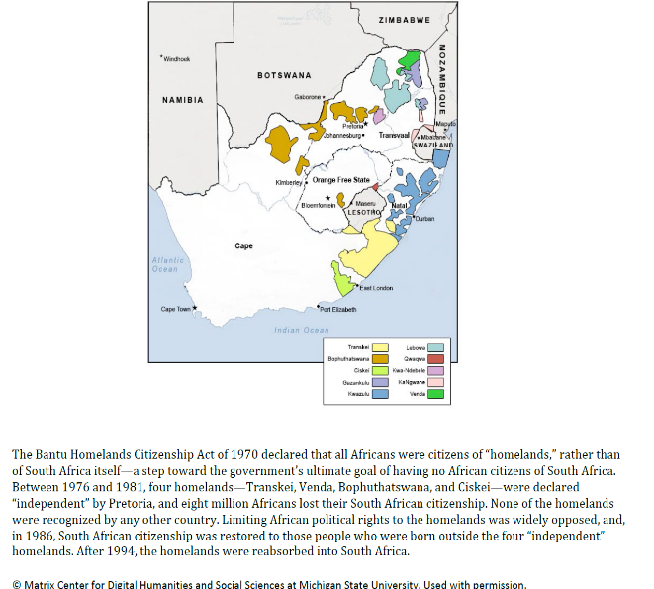

**Statement at a Special Meeting of the UN Special Committee Against Apartheid**

New York   June 22, 1990

These questions will arise because when this august body, the United Nations, first discussed the South African question in l946, it was discussing the issue of racism. They will be posed because the spur to the establishment of this organization was the determination of all humanity never again to permit racist theory and practice to dragoon the world into the deathly clutches of war and genocide.

And yet, for all that, a racist tyranny established itself in our country. As they knew would happen, who refused to treat this matter as a quaint historical aberration, this tyranny has claimed its own conclave of victims. It has established its own brutal worth by the number of children it has killed and the orphans, the widows and widowers it can claim as its unique creation.

And still it lives on, provoking strange and monstrous debates about the means that its victims are obliged to use to rid themselves of this intolerable scourge, eliciting arguments from those who choose not to act, that to do nothing must be accepted as the very essence of civilized opposition to tyranny.

We hold it as an inviolable principle that racism must be opposed by all the means that humanity has at its disposal. Wherever it occurs, it has the potential to result in a systematic and comprehensive denial of human rights to those who are discriminated against. This is because all racism is inherently a challenge to human rights, because it denies the view that every human being is a person of equal worth with any other, because it treats entire peoples as subhuman.

This is why it was correct to characterize the apartheid system as a crime against humanity and appropriate that the international community should decide that it should be suppressed and punishment meted out against its perpetrators. We pay tribute to this organization and its member states for this and other decisions and actions it took to expunge this crime.

Nelson Mandela

**Turning Point-** a turning point is a significant event, idea, or historical event that brings about change. It can be local, regional, national, or global.

**Identify** a turning point associated with the events, ideas, or historical developments related to ***both*** documents 1 and 2.

A turning point in the South African history is when Nelson Mandela became the president of the nation and spreading the message of how cruel the apartheid was.

**Explain** why the events, ideas, or historical developments associated with these documents are considered a turning point. Be sure to use evidence from ***both*** documents 1 and 2.

The apartheid system in South Africa discriminated and mistreated the native Africans. They were treated very harshly, and their human rights were violated. Their citizenship was removed and were exiled to the homelands, where they had limited rights. (**Document 1**) After struggling to fight for the rights of the African natives and ending the apartheid, Nelson Mandela would go to prison for years. After being let out, he became the president and spread the message of the apartheid, trying to spread awareness of the apartheid and get international help to ban the human rights violations of the apartheid.

**CRQ Set # 2**

**Document 1**

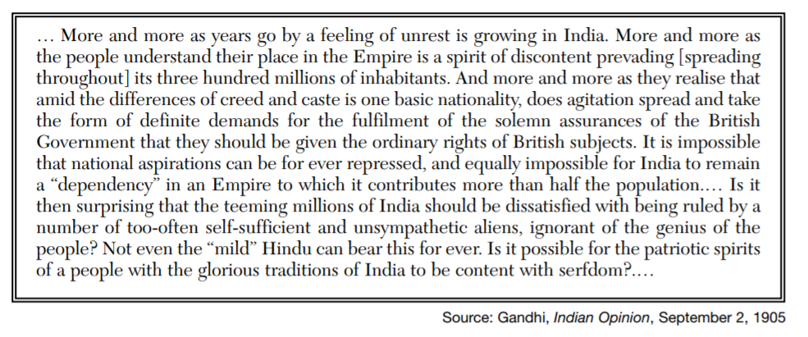

**Historical Context** – the historical circumstances surrounding this event/idea/historical development

Using document 1, **explain** the historical circumstances that led to the historical development in the document.

The British was in control of India throughout the 19th and 20th century. Gandhi wanted to make India independent and did so by protesting peacefully against the motherland. Indians did not receive proper rights or equal rights compared to the British. He protested through marches, speeches and boycotting. His non-violent independence movement against British rule gathered the attention of many who joined him to fight for freedom.

**Document 2**

Gandhi breaks the Salt Laws at Dandi beach, April 6, 1930.

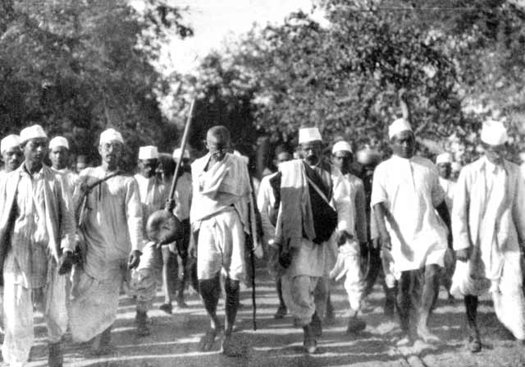

*Source: Mahatma Gandhi Foundation*

**Identify** and **explain** the purpose of this document.

Gandhi led a movement called the Salt March. British salt policies didn’t allow for Indians to collect or sell salt. Indians had to buy salt from Britain, which had a ridiculous tax on it. Gandhi promised that he will not act violently towards the British and led people to protest peacefully. Violating the salt law would be a peaceful protest. Thus, he told people to produce their own salt and the government weren’t able to arrest everybody. This resulted in the government forcing them to continue.

**Document 1 Document 2**





**Causation** – is a cause an effect relationship between events and ideas

**Identify** a ***cause-and-effect*** relationship associated with the events, ideas, or historical developments in documents 1 and 2.

The desire for independence and being dissatisfied with British rule (**Document 1**) caused protests and rebellions to occur. (**Document 2**)

**Explain** a ***cause-and-effect*** relationship associated with the events, ideas, or historical developments in documents 1 and 2. Be sure to use evidence from ***both*** documents 1 and 2 in your response.

The Indian’s lack of a say in the government and lack of rights caused people to protest against the British. The harsh government system caused many to work hard hours everyday and not being able to be content with working. (**Document 1**) Gandhi, being the leader of the independence movements would help lead them to India becoming independent. They did this by protesting and rebelling against the British peacefully, for instance, violating the salt law and not pay the salt taxes put by the British.